Steers or bulls are male cows
A Heifer is a female cow
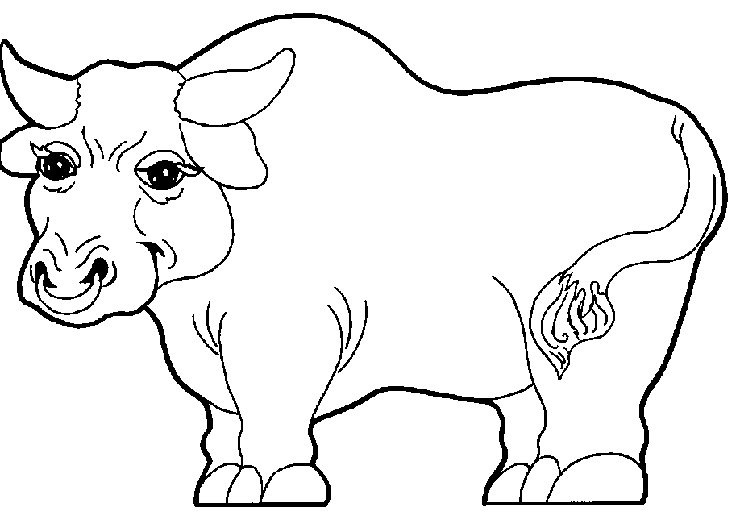
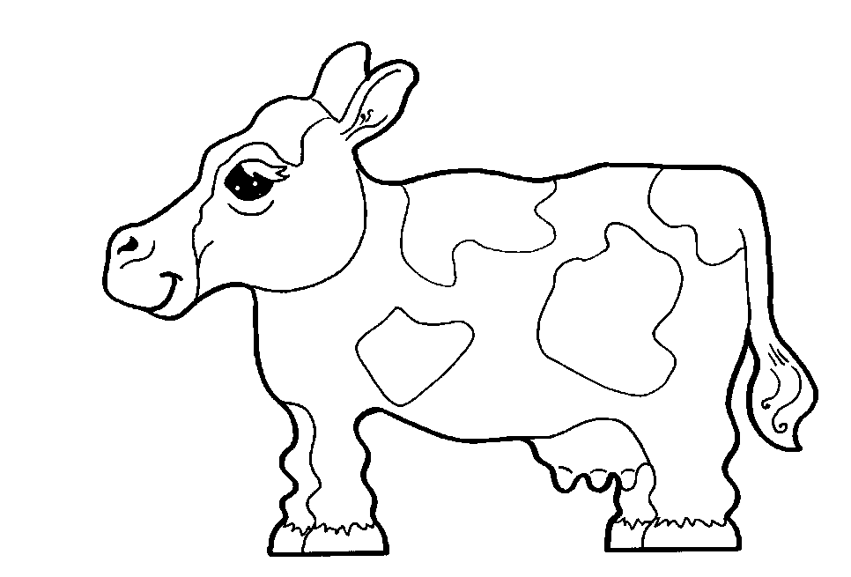
Which one is the Heifer?
We rescue day old cows called calves. The calves are mostly steers/bulls or dairy; Holstein or Jersey, with some beef calves. These calves would be a great 4-H project or a pet. All they need is you, a bag of powdered baby cow milk replacer and grain that you can get at the grange or farm store, and a safe home.

